Move Until Dark: Final Quiz (17 Pts)

Name________________________ Date_________

Answer each question below by including the question in your answer statement. An example would be, “What color was the red car?” Ans: “The color of the red car was red.” Use your own notebook paper, or you may complete it in Word or as the body of an email. For full credit, the email must be sent today, or a paper copy turned in at the beginning of class tomorrow.

1. How many blocks make up the basic version of Move Until Dark, and which blocks are they? (2)

2. What is a threshold? (1)

3. Once you have calculated the Light Sensor /threshold, which block do you use it in? (1)

4. What values do you need in order to calculate a Light/Dark threshold? (2)

5. Once you have found the values you need, how do you calculate the Light
Sensor Threshold? (1)

6. What function on the NXT lets you view sensor values on its screen? (1)

7. Explain what will happen in this program? (1)

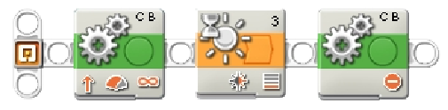

8.Would the robot classify the following Light Sensor readings as Light or Dark? (One word answers may be used with this question) (5)

a. Sensor reading of 18 with a Threshold of 42
b. Sensor reading of 58 with a Threshold of 38
c. Sensor reading of 50 with a Threshold of 56
d. Sensor reading of 17 with a Dark reading of 10 and a Light reading of 30
e. Sensor reading of 54 with a Dark reading of 43 and a Light reading of 62

9. Explain the behavior that will occur in the following program (3)

